As per the rule to Better Architecture and Code Review

<<https://rules.ssw.com.au/rules-to-better-architecture-and-code-review>>

# SSW (Mobile App)

SSW is doing a mobile app for NDC. It will allow attendees to earn points and win stuff.

After NDC SSW employees will also start to use the leaderboard as a gateway to do common tasks. Such as:

* Taking leave
* Seeing if you earnt a free lunch
* Purchasing requests. eg flights
* etc

## Frontend Choices

* **Option A: React Native + Web API (Recommended)**
  + Security – DONE - Proof of concept Azure AD B2C
  + Notifications = Good on iOS and Android
  + Homepage icon automatic
  + Test + Build + Deploy = Microsoft App Centre for iOS/Android distribution
  + **App Store: 2 Day Deployment = BAD (Once off)**
  + **Building iOS requires MacOS**
  + May help us change the Xamarin hack day to a mobile hack day
* Option B: React PWA
  + Security – EASY - Built-in support for ASP.NET Identity
  + **Notifications = BAD on iOS**
  + **Home page icon = BAD on iOS**
  + Test + Build + Deploy = Normal
  + Just need to add PWA bit and pieces
* Option C: Xamarin
  + Adam not keen on Xamarin because of lack of growth
  + Should be easy to develop in C#
  + Test + Build + Deploy = Microsoft App Centre for iOS/Android distribution
  + Not light-weight vs React Native (XAML vs Typescript)

Note: Redux or MobX

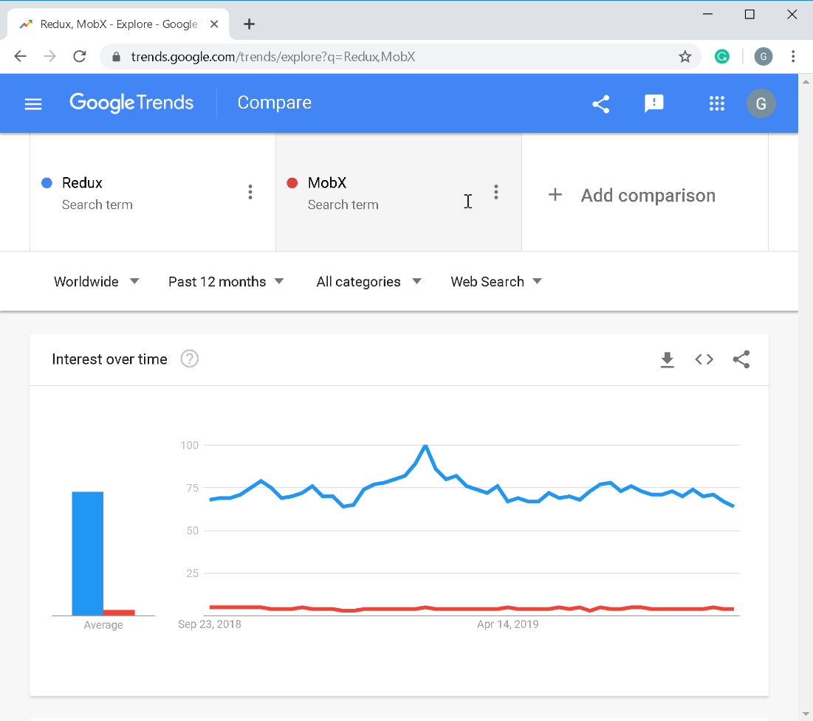

**Figure: Google Trends show Redux is more common in the industry**

## Features

**User Features**

1. Show leaderboard of user points
2. Get points - Scan QR code from SSW Employees
3. Get points – Do quiz
4. Get points – Tweet a rule or ssw video
5. Claim a reward
6. See the rewards to win

**Infrastructure Features**

* Login / Register through Azure B2C
* Scroll through onboarding section (UI only)
* Getting points
* Push notification when new points are earned
* Show rewards you’ve won (list of rewards)
* See list of SSW Employees
  + See who you’ve scanned
* Admin: Identify users who have won rewards
* Azure Logic App -> Finding retweets

## Authentication Choices

* **Option A: Completely new Identity Database + Azure AD B2C (Recommended)**
  + Separate to existing customer base (on CRM)
  + If necessary, we can sync this to CRM
* Option B: Use existing on-premise user database from ssw.com.au
  + Keep consistent customer identity
  + **Will require extra effort to integrate = BAD**

## Database Choices

Where to put tables?

TODO: List the new tables (Andreas)

1. **Option A: Azure Cosmos DB (Recommended)**
   * No migration headaches (Flexible schema)
   * SQL-Like query language
   * Take advantage of existing users
   * Scalable
2. Option B: On Prem SQL Server
   * Existing customer database (called SSWData2005) for consistent sign-in
   * **Slow = BAD**
3. Option C: Azure SQL Server
   * Relational model

## Technology Stack

Therefore, our technology stack is:

* Front End - React Native UI
  + Redux
* Web API - .NET Core 3 Web API
  + Logic Apps to connect w/
* Database - EF Core 3
  + Cosmos DB provider
* Authentication and Identity - Azure AD B2C

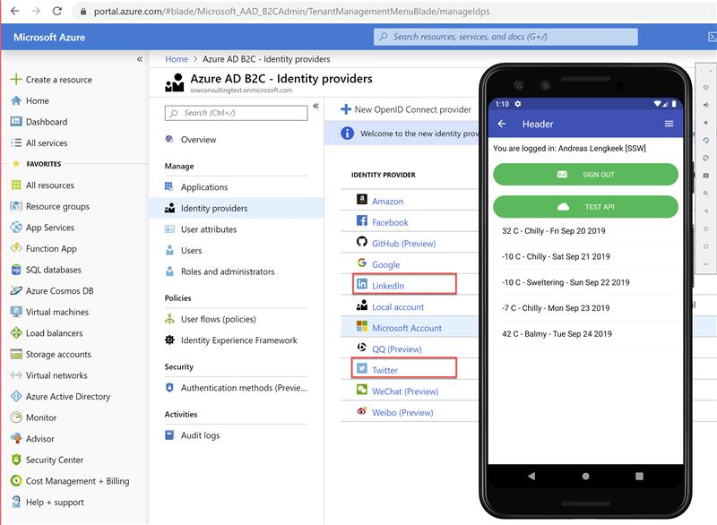**Figure: Azure AD B2C Identity Providers - we plan to use Local Account, Twitter and LinkedIn**

## Architecture and Design

Review <https://github.com/JasonGT/NorthwindTraders/tree/dotnetcore3/Src>

* React Native Client
* Web API
* Application
  + CQRS + MediatR
  + Interfaces for Infrastructure
    - IDbContext
    - IQrCodeGeneratorService
    - INotificationsService
  + Folders for features, e.g. Leaderboard
    - Queries
      * GetLeaderboard
  + Return a ViewModel that serves all needs of the view.
* Domain
  + Entities
* Infrastructure (this includes persistence)
  + Structure with folders:
    - Persistence folder
      * DbContext
      * Configurations
    - Authorisation
      * Authorisation concerns
    - Services
      * QrCodeGeneratorService
      * NotificationsService

## Database Models

* User (Name, Email, Password, Points)
* SSW Employees (Name, QR Code, Title, Bio, Headshot Image, Phone, Link to Site)  
  TODO:

## Backlog

TODO:

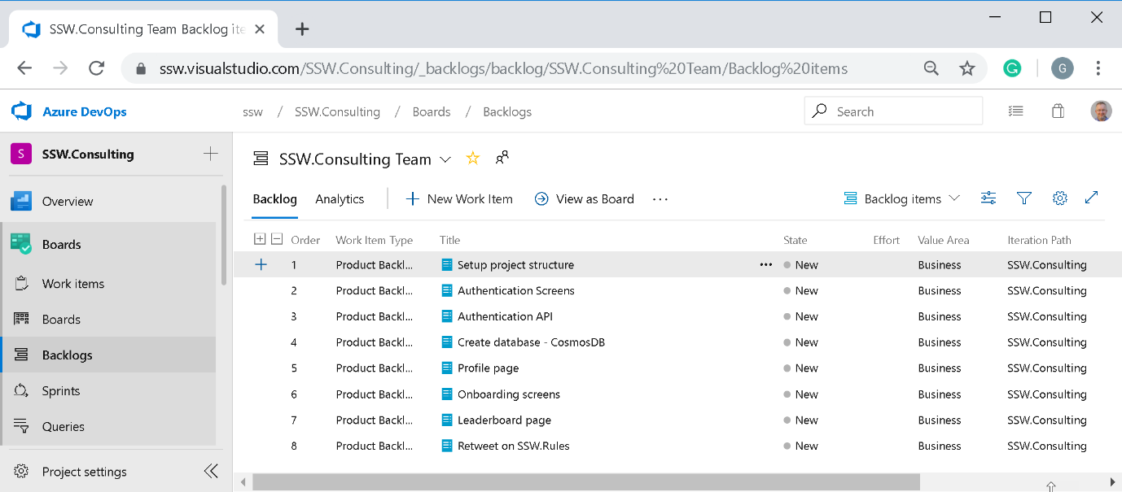<https://ssw.visualstudio.com/SSW.Consulting/_backlogs/backlog/SSW.Consulting%20Team/Backlog%20items>